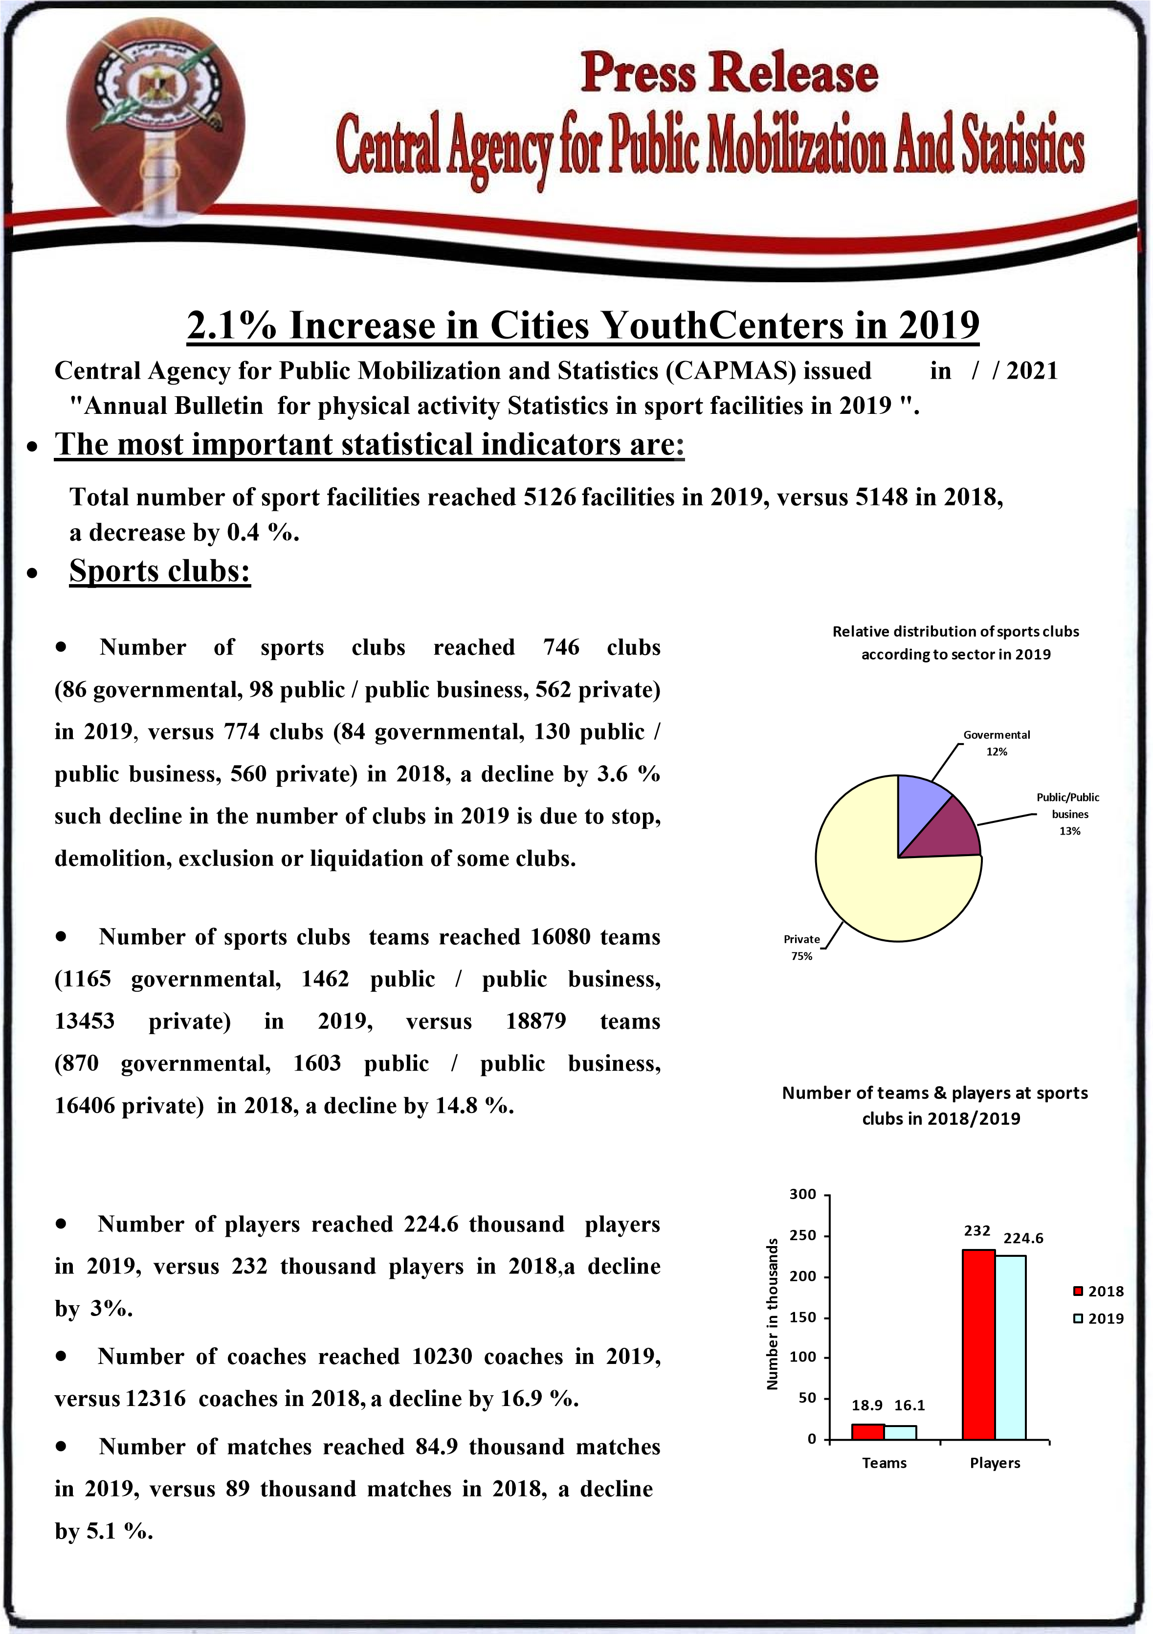

- Cities Youth Centres Number of teams & players at
- Number of centres reached 481 centres in 2019, cities ^{youth centres in 2018/2019} versus 471 centres in 2018, an increase by 2.1 %, as the number of teams reached 12.7 thousand teams in 2019, versus 13 thousand teams in 2018.
13.4
117
101
12
.7
0
20
40
60
80
100
120
140
Number in thousands

- Number of players reached 101 thousand players 2018 in 2019, versus 117 thousand players in 2018, a decline ²⁰¹⁹ by 13.6 %.
- Number of matches reached 35.3 thousand matches in 2019.
- Number of coaches reached 7219 coaches in 2019, Teams ^{Players} versus 6339 coaches in 2018, an increase by 13.9 %.

- Villages Youth Centres
- Number of centers reached 3899 centres in 2019 versus
3903 centers in 2018, a decline by 0.1 %, as the number Development of the number of villages/Cities
youth centers in 2018/2019 of teams reached 25.8 thousand teams in 2019 ,versus
29 thousand teams in 2018, a decline by 10.1%. ₃₉₀₃ ₃₈₉₉
- Number of players reached 264 thousand players in ⁴⁰⁰⁰ 2019, versus 249 thousand players in 2018, an increase ₃₀₀₀
by 6.1 % . ^{Villages}
481
47
1
- Number of matches reached 92 thousand matches in ²⁰⁰⁰ ^{Cities}
2019, versus 76 thousand matches in 2018 , an increase ₁₀₀₀ by 21.1%.
- Number of coaches reached 12237 coaches in 2019, ⁰
versus 11926 coaches in 2018, an increase by 2.6 %. ²⁰¹⁸ ²⁰¹⁹

Indicators for people with difficulties
- Number of teams with difficulties in sport clubs and youth centers at the Republic level reached 4407 teams in 2019.
- Number of players with difficulties in sport clubs and youth centers at the Republic level reached 28745 players in 2019.
- Number of matches for the players with difficulties participated was 14210 matches in various sports in 2019.
- Number of coaches for players with difficulties in sports clubs and youth centers at the Republic level reached 1897 coaches in 2019.

P.O. Box 2086 Salah Salem , Nasr City, Cairo, Egypt
Fax:)02(24024099 NCIS(phone): )02( 24050574 Public relation (phone):)02( 24020231 www.capmas.go.eg CAPMAS website: Email: pres_capmas@capmas.gov.eg

